**181 North Place Residences: Automated Monitoring System**

**Jefren Aguilar Kenneth Van Alimorong Ralph Daphene Bangsail**

Saint Louis University Saint Louis University Saint Louis University

School of Computing School of Computing School of Computing

and Information Sciences and Information Sciences and Information Sciences

Baguio City, 2600 Baguio City, 2600 Baguio City, 2600

[jefren.aguilar@gmail.com](mailto:jefren.aguilar@gmail.com) [kenneth101795@gmail.com](mailto:kenneth101795@gmail.com) [rdbangsail@gmail.com](mailto:rdbangsail@gmail.com)

**Mark Herbert Cabuang Helga Denise Galo Frances Mae Sabado**

Saint Louis University Saint Louis University Saint Louis University

School of Computing School of Computing School of Computing

and Information Sciences and Information Sciences and Information Sciences

Baguio City, 2600 Baguio City, 2600 Baguio City, 2600

markherbertcabuang [helgagalo1994@gmail.com](mailto:helgagalo1994@gmail.com) [frances.sabado@gmail.com](mailto:frances.sabado@gmail.com)

@gmail.com

**Kathreen Ann Silen Jaqueline Torres**

Saint Louis University Saint Louis University

School of Computing School of Computing

and Information Sciences and Information Sciences

Baguio City, 2600 Baguio City, 2600

[katkat.silen@gmail.com](mailto:katkat.silen@gmail.com) [jaqueline21.torres@gmail.com](mailto:jaqueline21.torres@gmail.com)

**ABSTRACT**

181 North Place Residences is a commercial dormitory that ensures the safety and security of their residents and transients. The management uses a paper-based system in their reservation, registration, and billing, the building administrator manually checks the logbook to know which resident exceeded the curfew hours, and then manually sends text message to the resident’s guardian or parents. The project proponents created an automated monitoring system using the current system of the dormitory that will help the management to process their operations effectively and efficiently. In creating the project, the proponents used the Incremental Process Model. By using the model, the proponent achieved their objectives in creating an automated monitoring system that uses a biometric device for the time-in and time-out of the residents.

The automated monitoring system created by the proponents helped 181 North Place Residences improve their monitoring operations because of the reduction of time-consuming tasks and helped the dormitory in the security and safety of the residents through the validation of the biometric device. Also, the automated system would be a beneficial tool on their daily operations as well as the dormitory’s future development.

**Categories and Subject Descriptors**

Information Technology

**General Terms**

Monitoring System

**Keywords**

FOWiz, Biometric

**1.**   **INTRODUCTION**

The automation of the monitoring system helps the management in gathering routinely information through the use of a fingerprint scanner. The fingerprint verification for the automated monitoring system uses a biometrics technology to validate the input with the image based method or matching pattern. Biometric technologies [2] are defined as automated methods of identifying or verifying the identity of a living person based on unique biological (anatomical or physiological) or behavioral characteristics. Biometrics can provide very secure and convenient verification or identification of an individual since they cannot be stolen or forgotten and are very difficult to forge. (Smart Card Alliance, March 2011)

The 181 North Place Residence is a commercial dormitory for residents and transients. The management processes transactions such as reservation and registration of a resident or a transient manually using paper-based forms. The management also uses Microsoft Excel 2007 for computations of fees and balances of the residents and transients. A logbook is being used in monitoring the time-in and time-out of each resident. In notifying the guardian and/or parents of the residents about violations and other concerns, the management sends text messages through a mobile device and/or sends e-mail.

The project aims to automate the reservation, registration of admin, resident, and transient, billing, time-in and time-out of residents with the use of fingerprint scanner, activation, notification, create a credential for the management using admin module, report generation, backup and recovery and help module. The system helps the management to process operations faster, accurate, effectively and efficiently.

**2.**   **METHODOLOGY**

**2.1 Software Development Used in the Project**

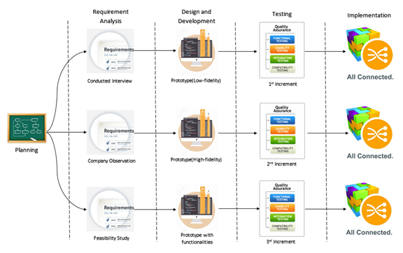

**Figure 1. Incremental Process Model**

The project proponents used the Incremental model [1] of Mr. Winston W. Royce in developing the system to include clients or customer involvement on the developing stages and increments.

**2.1 Increments**

In the Planning Phase the project proponents conducted a series of interviews, researches, and consultations with professionals, and understand the business process and policies of the monitoring system of the 181 North Place Residences to gather information that served a the fountain in the development of the monitoring system.

In the Requirement Analysis Phase, the project proponents found necessary resources that helped in designing and developing the monitoring system. The project proponent used the Data Flow Diagram (DFD) as a tool to present and picture the business processes of the monitoring system.  The project proponent used storyboard to present the proposed system by the management of 181 North Place Residences and flowchart to show the current operations of the 181 North Place Residences and easily identify the marks of process development.

In the Design and Development Phase, the project proponent used wireframes as the initial step in designing the user interfaces to be developed. In the development of the high fidelity user interfaces (UIs) of the system, the project proponent used Integrated Development Environment (IDE) Netbeans 8.0.1., phpMyAdmin and MySQLWorkbench for the Database management.

In the Testing Phase, unit testing was performed to each module by a member of the team. After the unit testing, the integration of the modules was performed and the integration testing was done. Version one of the system was tested by the management of 181 North Place Residences. After testing, revisions and suggestions were given. The project proponent then made the necessary revisions. After that, unit and integration testing were performed again.

In the Implementation Phase, the project proponents conducted a deployment for every module done and suggestions from the management were raised. And for every revision done based from the suggestions of the management, a new version of the module was deployed. The project proponents continued to develop and deploy the system until the management was satisfied with the monitoring system and had signed the acceptance letter.

**3.**   **RESULTS AND DISCUSSIONS**

**3.1 System Architecture**

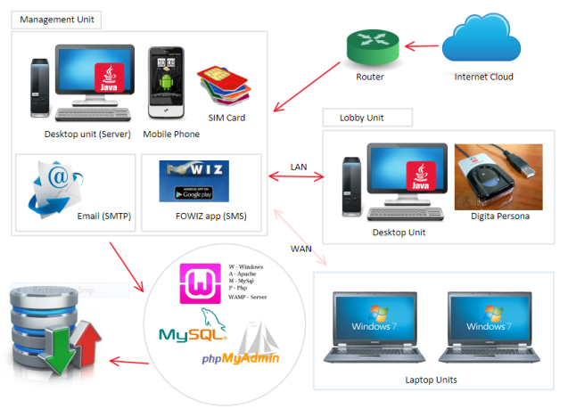

**Figure 2. System Architecture**

The system architecture is comprised of two major components to execute the business processes of the automated monitoring system.

Figure 2 explains the different connection and communication of the different components in the system.

The management unit holds as the server for the system to facilitate the automated monitoring system. The unit is connected with the android mobile phone with a post-paid bill and a Fowiz application [3] for the sending of text-messages. The unit also facilitates sending email messages using SMTP protocol. The unit holds the database of the system. The unit is connected to the internet.

The lobby unit is intended to process the time-in and time-out capture of the residents. The unit is connected with the biometric device. The communication between the management unit and lobby unit can either be wireless or wired connected, that is different laptops can also be connected with the system.

**3.2 Client Server Architecture of the Automated Monitoring System**

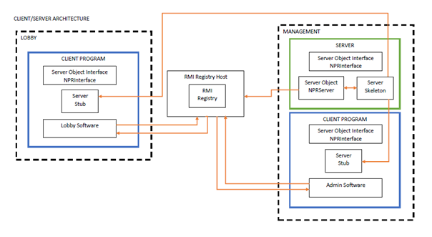

**Figure 3. Client Server Architecture**

Figure 3 is the Client/Server Architecture of the system which is implemented in Java Remote Method Invocation (Java RMI). The Server is implemented with the same interface (NPRInterface) called by the client program. There are (2) two client programs calling NPRInterface, which is the Lobby and Managament application. The server creates an RMI Registry to serve as the communication between the client program to the server. The skeleton of the server is connected to the stub in the client programs for their communication.

**3.3 Management Unit Modules**

The management unit is a component that performs as the server for the system. The management unit is a desktop unit connected with fiber-optic internet connection. An android mobile phone with a SIM card subscribed to a post-paid bill, preferably only for texting, is also connected to the management unit for the sending of text messages. The email sending will be done through SMTP protocol. The android mobile phone is installed with FOWiz application downloaded at Google Play Store for free. The android mobile phone is connected to the internet. The following are the modules of the Management Unit:

|  |  |
| --- | --- |
| **Modules** | **Description** |
| Reservation | The module for reservation input and data will be stored in the reservation table in the database. |
| Registration | The module for the registration input for residents and transients and data will be stored in the registration table in the database. The visitor registration will be fetched from the lobby unit and will be saved to the database. |
| Activation | The module to activate selected residents to access the time-in and time-out module. |
| Time-in and Time-out | The module to capture the time-in and time-out of residents and data will be stored in the logs table in the database. |
| Billing | The module to process balances and fees of the residents. |
| Notifications | The module to search and find data being stored in the database. |
| Report Generation | The module to process the reports needed by the management. Data being processed will be transformed into information useful to the management. |

**3.4 Lobby Unit Modules**

The lobby unit is a component to serve as the data entry for the system. The lobby unit is a desktop unit connected to the biometric device for the time-in and time-out module. The data entered in the lobby unit will be displayed in the management unit. The connection to the server will be through Wide Area Network. The following are the modules of the Lobby Unit:

|  |  |
| --- | --- |
| **Module** | **Description** |
| Time-in and Time-out | The module to allow residents input their time-in and time-out logs. |
| Query | The module to search a resident. |
| Registration | The module for the registration input for visitors and data will be displayed in the management unit. |

**4.**  **CONCLUSIONS**

The project was intended to automate specific business processes of 181 North Place Residences, developed a computer-based system with functional requirements that helped the management to process operation effectively and efficiently, defined and integrated the tools and technologies for the development and implementation of the monitoring system.

The key findings and arguments of the project is it helped the monitoring system of 181 North Place Residences to be effective and efficient in keeping time records and notifying residents, the project also lessened the time of the management in processing transactions of every resident and transient. In the system, the management is able to monitor the resident who uses the biometric device through the unit and choose who to send notifications. The system also helped the management in tracking the inventory and computing the bills. The system keeps records to have basis in reports.

**REFERENCES**

[1]Incremental Development Methodology. (n.d.). Retrieved November 11, 2014, from (<http://www.qmetry.com/incremental.html>)

[2]Alliance, S. (2011). Smart Cards and Biometrics - FINAL - 030111 - Iris ID. Retrieved from<http://irisid.com/download/news/Smart_Cards_and_Biometrics_030111.pdf>.

[3](2014). FOWiz SMS Integration API | ProgrammableWeb. Retrieved February 3, 2015, from<http://www.programmableweb.com/api/fowiz-sms-integration>.

**GROUP PICTURE**

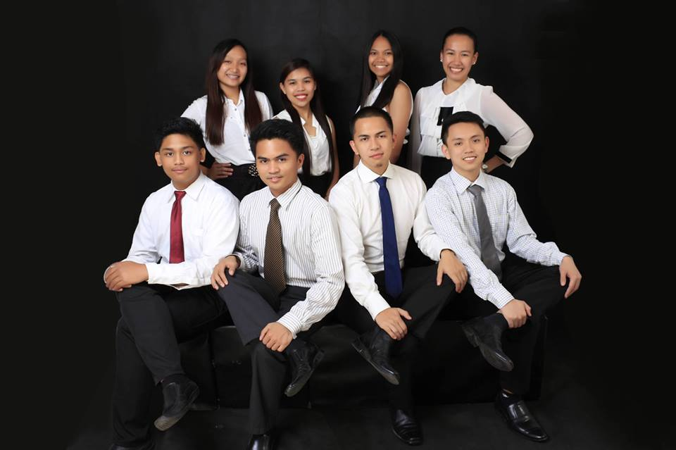

(Upper left to lower right): Jaqueline L. Torres, Kathreen Ann G. Silen, Frances Mae N. Sabado, Helga Denise B. Galo, Kenneth Van L. Alimorong, Jefren R. Aguilar, Ralph Daphene B. Bangsail, Mark Herbert D. Cabuang